**IMPORTANT – before you start doing your solution, MUST do the following steps:**

1. Create your MS SQL database named **PRJ311 by running code in script**

[**PRJ311DB.sql.**](https://drive.google.com/open?id=1wWAy2AY2MCLgY3ZtzsY3Sm0JcGZw61-E)

1. **You MUST use DBContext.java for your all database connection.**
2. **Use** [**Given project**](https://drive.google.com/open?id=1k0pVvMn7GBhFgI84FMxqcARCf8qE65fR) **for this solution**

**Question 3: (4.0 Point)**

Design the form might look something like figure below, named the java file is **AOutcome.java** (**0.5 Point**)

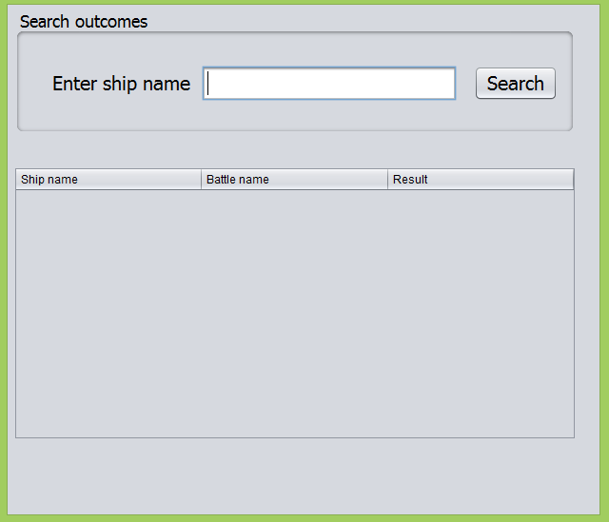

When users enter value for ship name and click Search button, output information of all outcomes in Outcomes table to below table which have ship name contains entered value (**2.0 Point**) also output the number of rows/records found **(0.5 Point)**.

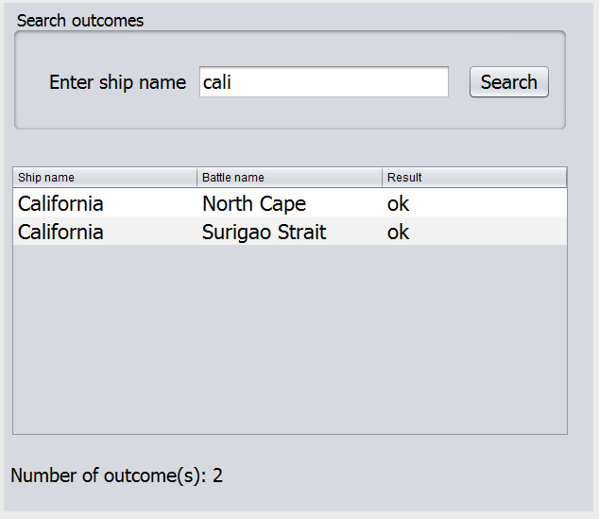

Output a message “Not found any Outcome” if the system could not find any matched Outcome (**1.0 Point**).

